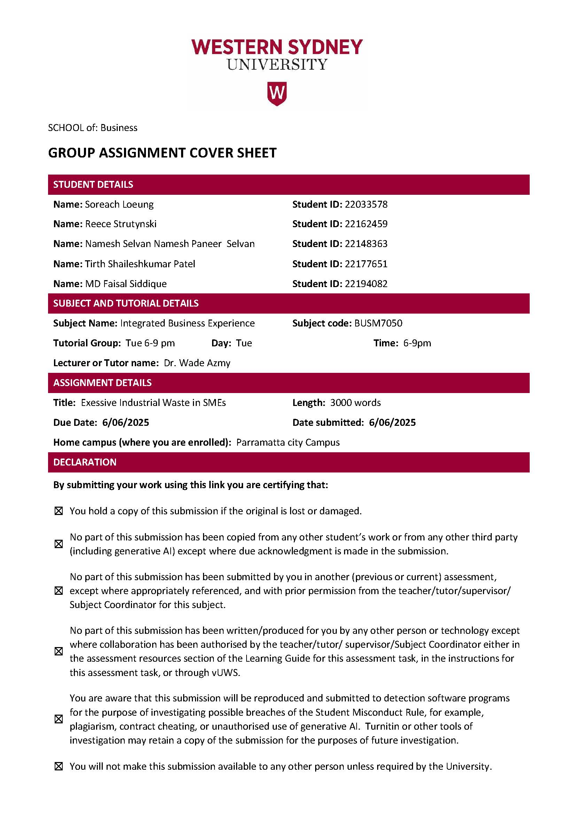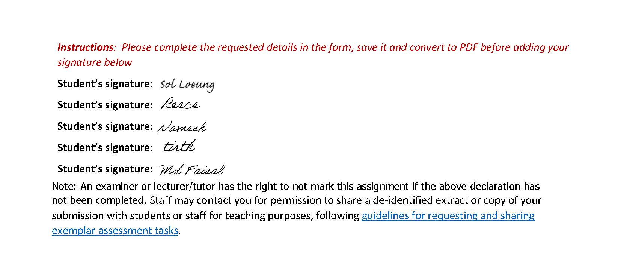

1. Executive Summary
Small-to-medium enterprises (SMEs) constitute over 93% of Australia's manufacturing sector, yet they disproportionately contribute to industrial waste due to limited access to recycling infrastructure and circular economy solutions (Department of Industry, Science and Resources, 2022). This inefficiency results in significant resource loss and environmental degradation. For instance, Australia's current circularity rate stands at a mere 4.4%, indicating substantial room for improvement in resource recovery and waste reduction (Australian Bureau of Statistics, 2023).
To address this challenge, we propose a physical circular economy platform that connects SME manufacturers with upcycler, recyclers, and sustainable material marketplaces. This platform aims to facilitate the repurposing of industrial waste, transforming it into valuable inputs for other processes, thereby reducing landfill dependency and promoting sustainable practices.
Our Business Model Canvas (BMC) outlines key components: SME manufacturers and recyclers as primary customer segments; value propositions including cost savings, new revenue streams from waste materials, and enhanced sustainability credentials; channels such as digital platforms and industry associations; and revenue streams from subscription fees and data insights. Key resources involve platform technology and partnerships with government agencies and logistics providers.
This initiative aligns with three United Nations Sustainable Development Goals (SDGs): SDG 9 (Industry, Innovation, and Infrastructure) by fostering sustainable industrial practices; SDG 12 (Responsible Consumption and Production) through waste reduction and resource efficiency; and SDG 13 (Climate Action) by mitigating greenhouse gas emissions associated with waste.
By enabling SMEs to integrate into a circular economy, this platform not only addresses environmental concerns but also offers economic benefits, including potential cost savings and new business opportunities, contributing to a more sustainable and resilient manufacturing sector in Australia.

2. Introduction:
Industrial manufacturing is a cornerstone of Australia's economic and industrial landscape, contributing significantly to employment, innovation, and export earnings. The sector encompasses food processing, metal products, chemicals, machinery, and advanced manufacturing technologies. As of 2023, manufacturing contributed approximately $124 billion to Australia's GDP and employed around 900,000 workers (Australian Industry Group [Ai Group], 2023). While large manufacturers dominate export activities, over 93% of manufacturing firms are small and medium-sized enterprises (SMEs) (Department of Industry, Science and Resources, 2022).
One of the key challenges facing the manufacturing sector is resource inefficiency and waste generation. According to Sustainability Victoria (2020), the manufacturing industry is the second-largest contributor to industrial waste in the state, generating approximately 1.3 million tons of waste annually. Across the country, the sector generates over 4.3 million tons of waste per year, with significant contributions from metal, plastic, food, and chemical industries (CSIRO, 2021). Many SMEs lack the financial and technical resources to implement advanced waste management solutions, resulting in excessive landfill use and lost productivity.
Addressing waste is not only an environmental concern but a strategic imperative. Research has shown that Australian manufacturing SMEs could reduce material waste by up to 20% and energy waste by 10–15% through the adoption of lean manufacturing and circular economy principles (Mekonnen et al., 2021). Moreover, according to the National Waste Report (Department of Climate Change, Energy, the Environment and Water, 2022), industrial waste accounts for 22% of all waste generated in Australia, placing pressure on governments and businesses to find sustainable alternatives.
Transitioning to sustainable manufacturing practices, such as resource-efficient design, energy-efficient technologies, and waste valorisation, is essential. Doing so enables SMEs to reduce costs, meet regulatory requirements, and gain competitive advantage in a market increasingly driven by environmental, social, and governance (ESG) standards.
3. Identification of the Problem
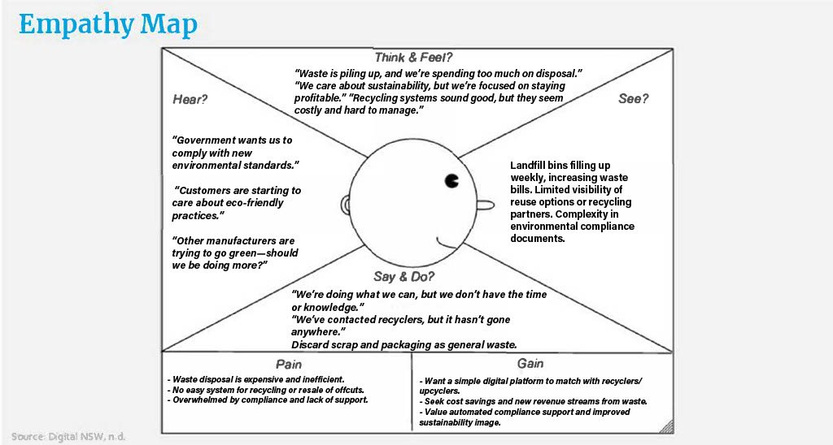
Small and medium-sized enterprises (SMEs) in Australia are consistently producing an increasing amount of industrial waste, which is detrimental to both the environment and the business. They frequently discard this waste, which is primarily composed of excess materials from production, packaging, and damaged items, rather than recycling or reusing it.
The Commonwealth Scientific and Industrial Research Organisation (CSIRO) says that Australia's manufacturing industry makes more than 8 million tonnes of waste every year. Small and medium-sized businesses (SMEs) are important because their systems are broken, and they don't always follow the same rules for getting rid of trash. Sustainability Victoria (2022) said that many small and medium-sized businesses (SMEs) don't know about circular economy solutions or can't get to the right infrastructure, which makes the problem worse.
It's not enough for small business owners to just notice the problem; they also need to do something about it and get help. The rising costs of getting rid of trash, which can be between $10,000 and $20,000 a year, make many small business owners and managers feel like they can't handle it (Clean Energy Regulator, 2022). Wanting to do things that are good for the environment and having a stable financial future are two things that don't go together. A business owner might say, "We're throwing away too much trash, and it's piling up." It sounds good to recycle, but it seems like it costs a lot and is hard to do.
The same things that SMEs are hearing are happening in the bigger world: government rules are getting stricter, customers want businesses to be more eco-friendly, and competitors are becoming more eco-friendly. But small and medium-sized businesses (SMEs) don't often find many useful recycling partnerships or compliance tools that are easy to use. It's even harder to deal with because environmental documents are hard to understand and there isn't much help.
A lot of small and medium-sized businesses say and do what they can, but it hasn't worked out. "We've called recyclers, but it hasn't gone anywhere." Because of this, people still throw away useful things with their regular trash. They have big problems, like high costs for getting rid of things, rules that aren't clear, and systems that don't work well for reusing or selling offcuts.
SMEs also want to make money at the same time. They are actively looking for easy-to-use digital platforms to connect with recyclers, tools that help them stay compliant automatically, and ways to make money from trash. They want to be more environmentally friendly, but they need solutions that work with what they already have and can do.
Too much industrial waste is bad for the environment and for business. It makes small and medium-sized businesses in Australia less efficient, less competitive, and less socially acceptable. We need to know more than just the waste metrics to fix this problem. We need to know what it's like to run a small or medium-sized business, what drives them, and what their limits are.

4. Identification of the Industry Landscape
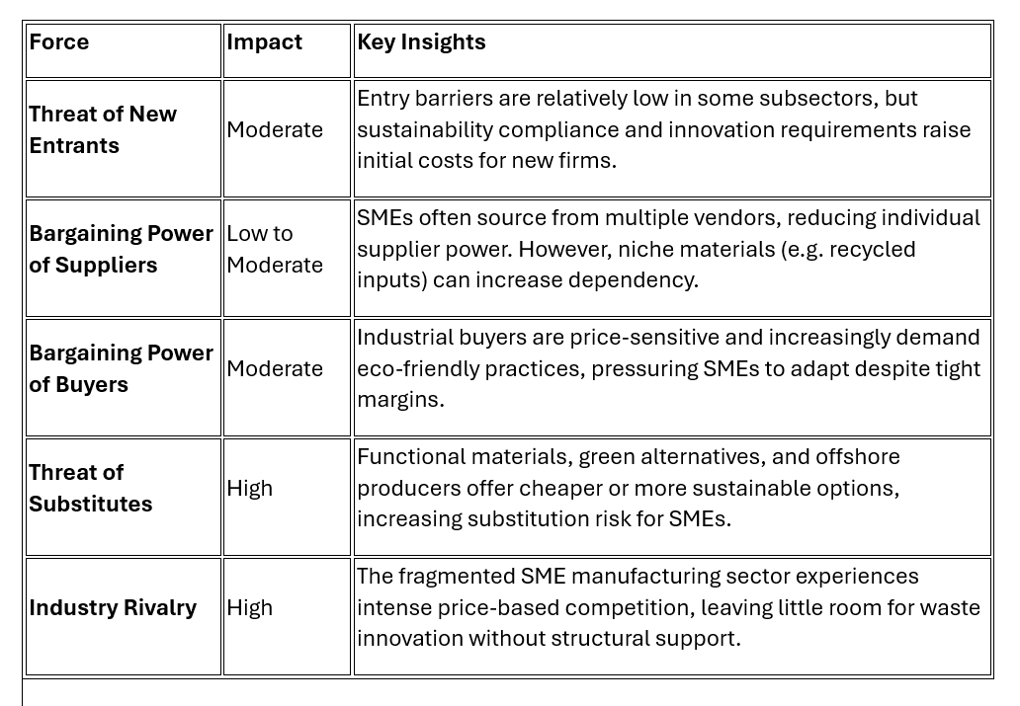
Small and medium-sized enterprises (SMEs) in Australia encompass a diverse range of industries, including food processing, metal manufacturing, plastics, textiles, and construction materials. SMEs, described as having fewer than 200 people, make up almost 95% of all manufacturing activities in Australia (Australian Bureau of Statistics, 2022). They are an essential yet delicate aspect of the industrial ecology.
Big companies are starting to care more about sustainability, but small and medium-sized businesses (SMEs) have a lot of problems, such as not having enough money, not knowing the best ways to do things, and not being able to get government incentives that are right for them. In term of digital resources and infrastructure, many SMEs are severely underequipped to track, recycle, or upcycle. Typically, when companies dispose of waste, they do not give it any consideration. This void was demonstrated by studies conducted by the Advanced Manufacturing Growth Centre (AMGC, 2021). Despite advancements in the field thanks to technological advancements, the report states that SMEs still do not implement the circular economy.
The National Waste Policy Action Plan (2019) wants to cut waste by 10% per person by 2030 and encourage recycling. The regulations, however, are difficult for many of these SMEs to adhere to. Regulatory requirements are good, but they often don't have support systems that work for smaller businesses with niche business models. A lot of local councils and waste service providers also don't have solutions that are made just for small to medium-sized enterprises (SMEs), so the only solution to get rid of waste is through landfill.
To get a better idea of the competitive and structural forces that are affecting this industry, the Porter’s Five Forces framework can help:
These factors show how weak the structure of SME manufacturers is since they work with small profit margins, face more policy pressure, and have trouble finding scalable waste solutions. Without help or a way to work together on waste, small and medium-sized businesses find it hard to turn sustainability from a cost into a competitive advantage.
In short, the current state of the industry shows that we need scalable, sector-specific solutions, like a digital circular economy platform, to close the gap between environmental compliance, operational capacity, and economic opportunity.

5. Identification of Innovation:
A circular economy platform is an innovative system designed in a physical or digital form to encourage the material recycling, which encourages to minimise the waste and promote sustainability. The platform works with a reduce, reuse and recycle model, which aims to use the resources for a longer period by extracting maximum value from the material before renewal, unlike the traditional linear model of extracting, producing and discarding. (Noor Ul Hadi, Balqees Almessabi & Muhammad Imran Khan 2025)
Physical circular economy platforms are about the creation of usual central offices or workshops from where goods could be gathered, classified, and readdressed. Quite often these gathering points are not just ordinary ones but the centres of innovation, which attract and unite several interest holders, such as manufacturers, recyclers, and designers, seeking to work together on projects for sustainable solutions and to create product designs that would enable the easier processing of the materials for recycling and reuse. There, sustainable and circular material loops are made functional, as they shift the focus from conventional reuse and repurposing to the more basic issues of consumption and resource use (Jillian Neuberger, Till Weidner & Ed Steane 2019).

6. Business Model / Value Chain:

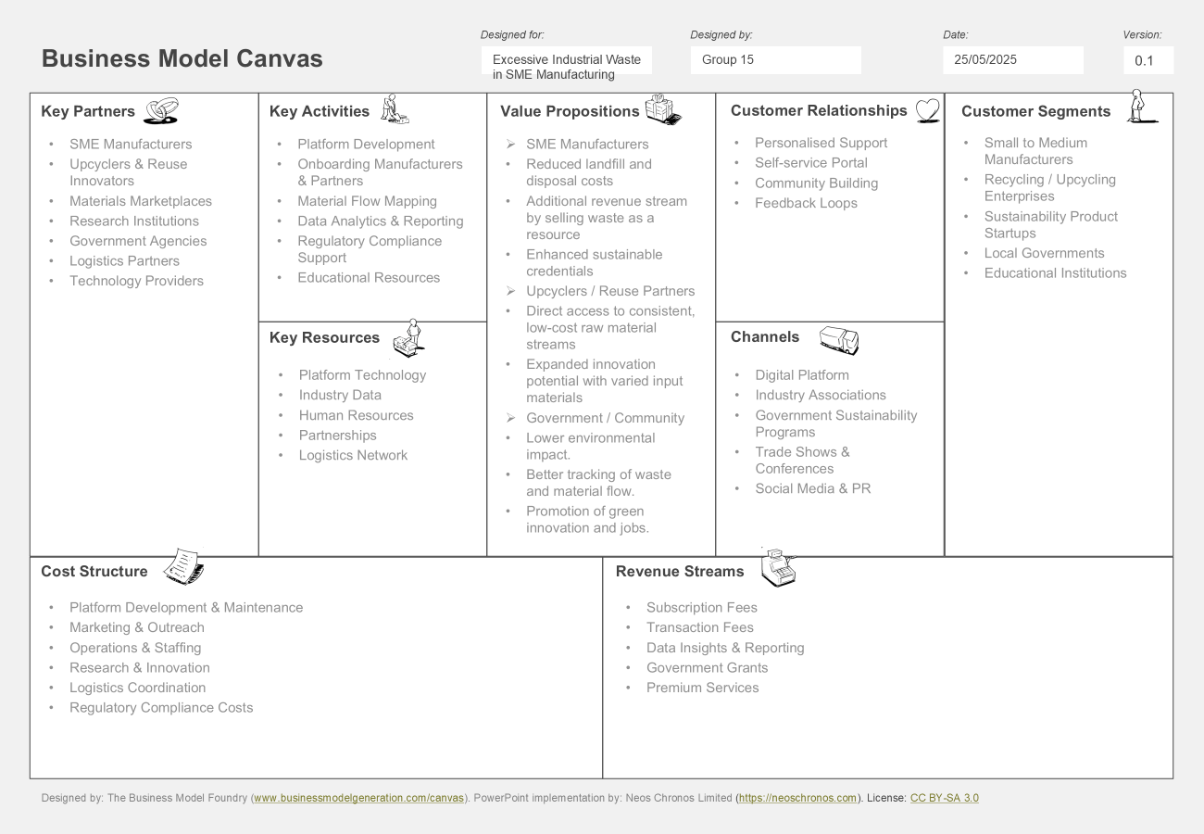

- Customer Segment:

- Small to Medium Manufacturers: The major contribution towards industrial waste is made by small to Medium Manufacturers.
- Recycling/Upcycling Enterprises: Transform waste items into products that can be used.
- Sustainability Product Startups: Industry leaders are exploring sustainable materials for an effective supply chain.
- Local Governments: Emphasise eco-friendly practices and the use of sustainable resources.
- Educational Institutions: To explore tools for data driven studies, experiments, and innovative solutions.

- Value Propositions:

For SME Manufacturers:
- Reduced Landfill and Disposal Costs: Divert excess resources towards sectors working on sustainable trade networks.
- New Revenue Stream: Turning waste materials into surplus resources for economic gains.
- Sustainability Credentials: Building corporate reputation by creating eco-friendly products.

For Upcyclers/Reuse Innovators:
- Consistent Supply of Materials: Economically effective and dependable supply of recycled materials.
- Innovation Potential: Exploring creative potential for transforming unique resources.

For Government/Community:
- Lower Environmental Impact: Optimising industrial waste, carbon emission, and eco-friendly production.
- Improved Waste Tracking: Clear transparency in reporting and reliable governance.
- Green Job Creation: Encourages emerging business initiatives and employment in the sustainability sector.

- Channels:

- Digital Platform: Essential platform for user engagement.
- Industry Associations: Enhance platform awareness through reliable networks.
- Government Sustainability Programs: Promote engagement drives through strategic incentives and assistances.
- Trade Shows & Conferences: Demonstrate the strengths and benefits of the system.
- Social Media & PR: Promote market visibility, celebrate positive results, and encourage involvement.

- Customer relationships:

- Personalised Support: Expert onboarding assistance, problem-solving, and performance improvement.
- Self-service Portal: Offer seamless service with direct control over data.
- Community Building: Engagement drives for knowledge sharing, virtual events, collaborative initiatives.
- Feedback Loops: utilise the feedback from customers to enhance the platform performance.

- Revenue Streams:

- Subscription Fees: Subscription based membership fees for platform usage.
- Transaction Fees: Distribution fee for every completed material transfer.
- Data Insights & Reporting: Provide data driven analysis and market intelligence for purchase.
- Government Grants: Capital funding for impactful projects based on the use of sustainable materials.
- Premium Services: Personalised support for operational efficiency through logistics and supply chain, compliance governance, and promotional strategies.

- Key Resources:

- Platform Technology: Scalable digital system with end-to-end architecture, AI-driven models with real-time engagement.
- Industry Data: Comprehensive data insights for efficiency in waste management, and use of eco-friendly materials.
- Human Resources: Allocating skilled person for system maintenance, industry analysis, and learning new resources.
- Partnerships: Cross functional industry collaborations, policymakers, transportation, and distribution networks.
- Logistics Network: Strategic supply chain network for effective handling of materials, storage and efficient dispatch.

- Key Activities:

- Platform Development: Building digital connectivity for streamlined platform for business transactions.
- Onboarding Manufacturers & Partners: Emphasising active involvement from circular economy innovators.
- Material Flow Mapping: Analysing and mapping waste streams for recycling and redistribution.
- Data Analytics & Reporting: Detailed evaluation of key metrics for analysing consumer trends, regulatory tracking and operational transparency.
- Regulatory Compliance Support: Provide compliance governance by creating environmental policies and sustainability standards.
- Educational Resources: Offering resources that provide the awareness about sustainability and usage of eco-friendly materials.

- Key Partners:

- SME Manufacturers: Essential contribution towards material recovery and usage of sustainable resources.
- Upcyclers & Reuse Innovators: Sustainability Innovators and enterprises are converting waste into creative and valuable products through recycling platforms.
- Materials Marketplaces: Digital platforms like e-commerce marketplace are used for streamlining waste recovery and recycling.
- Research Institutions: Collaboration with innovation hubs and research centres for providing new sustainable approach towards manufacturing.
- Government Agencies: Government regulatory bodies provide financial support and promote sustainable resource management.
- Logistics Partners: Streamline supply chain for effective transportation and sustainable storage.
- Technology Providers: Technologies that provide advanced digital enhancement like operational intelligence and decision making via AI.

- Cost Structure:

- Platform Development & Maintenance: Application and software providing creating maintenance and perform upgrade.
- Marketing & Outreach: Creating awareness through product visibility and engagement with participants.
- Operations & Staffing: Allocating funds for staffs and research professional.
- Research & Innovation: Cross functional collaboration for research & development through education.
- Logistics Coordination: Costs for managing supply chain & logistics for storage, pick-up and delivery.
- Regulatory Compliance Costs: Ensuring regulatory compliance.

7. Sustainability Initiatives (3 UNSDGs):

The United Nations Sustainable Development Group (UNSDG) is a group of over 30 United Nations agencies, programs, and funds that work together to support each and every country in achieving the Sustainable Development Goals.
There are a total of 17 goals under the UNSDG. During the solution of Excessive Industrial Waste in SME Manufacturing, we cover three of them: SDG 9, SDG 12, and SDG 13.
SDG 9: Industry, Innovation, and Infrastructure
The goal is to build resilient infrastructure, promote sustainable industrialization, and foster innovation. To solve the industrial west problem, many companies introduce new innovations and change their business infrastructure to reduce manufacturing waste.
As an example: Samsara Eco (a Sydney-based biotech startup) is working in this area. They develop enzyme-based plastic recycling technology to fill the loops in the manufacturing process to reduce waste.
SDG 12: Responsible Consumption and Production
This goal stands for sustainable consumption and production patterns. By reducing waste, we can save our natural resources for future generations. By using sustainable practices, we can improve the environment and quality of life.
For example, Planer Ark (an Australian environmental foundation) makes a partnership with businesses in their sector to help companies improve packaging and recycle rates. They provide the solutions to the SMEs on how to reduce the usage of natural resources.
SDG 13: Climate Action
To achieve this goal, companies are working towards reducing the impacts of climate change. Because climate change is the reason behind natural disasters, global warming, and rising sea levels. We need to take measures to reduce climate change.
For example, Allied Heat Transfer (Queensland-based SME) designs and manufactures energy-efficient heat exchangers and cooling systems for industrial use. By using this kind of technology, businesses can reduce carbon emissions and energy waste.
All three SDGs are covered under the solution of excessive Industrial Waste in SME manufacturing.

8. Economics / Financial Analysis:

In Australia there are several industrial waste management companies operates like Cleanaway waste management limited, Toxfree solutions and JR Richards & Sons.
Here, we work out Cleanaway's Break-Even Point (BEP), one of Australia's largest waste management companies. The BEP determines how much waste the company needs to process to break even—that is, without profit or loss. We use the formula: Break-Even Point (Units) = Fixed Costs ÷ (Selling Price per Unit – Variable Cost per Unit).
Cleanaway is working in a sector like manufacturing waste management. For Cleanaway, the fixed costs are approximately $495.2 million for infrastructure, equipment, and wages. It includes fleet operating expenses are approximately $198.7 million, property expenses are approximately $36.3million, salary expenses are $77.6 million, and depreciation and amortization expense are approximately $182.6 million this costs that remain the same regardless of the volume of waste processed. The selling price per unit, which is revenue obtained per tonne of waste processed, is approximately $387.50, and the variable cost per unit, which includes fuel, transport, and processing, is $301.10. Plugging these numbers into the formula gives: BEP = 495.2 million ÷ (387.5 – 301.1) = 495.2 million ÷ 86.4 ≈ 5.73 million tonnes. This means that Cleanaway needs to handle approximately 5.73 million tonnes of waste annually just to break even. It is important to know this threshold because handling more than this amount results in profit, and less than this causes a financial loss—a major indicator of financial and operational sustainability. The reference of this data is the annual financial report of 2023-2024.

9. Balanced Scorecard (BSC) Analysis:

Balanced Score card (Draft by Reece)
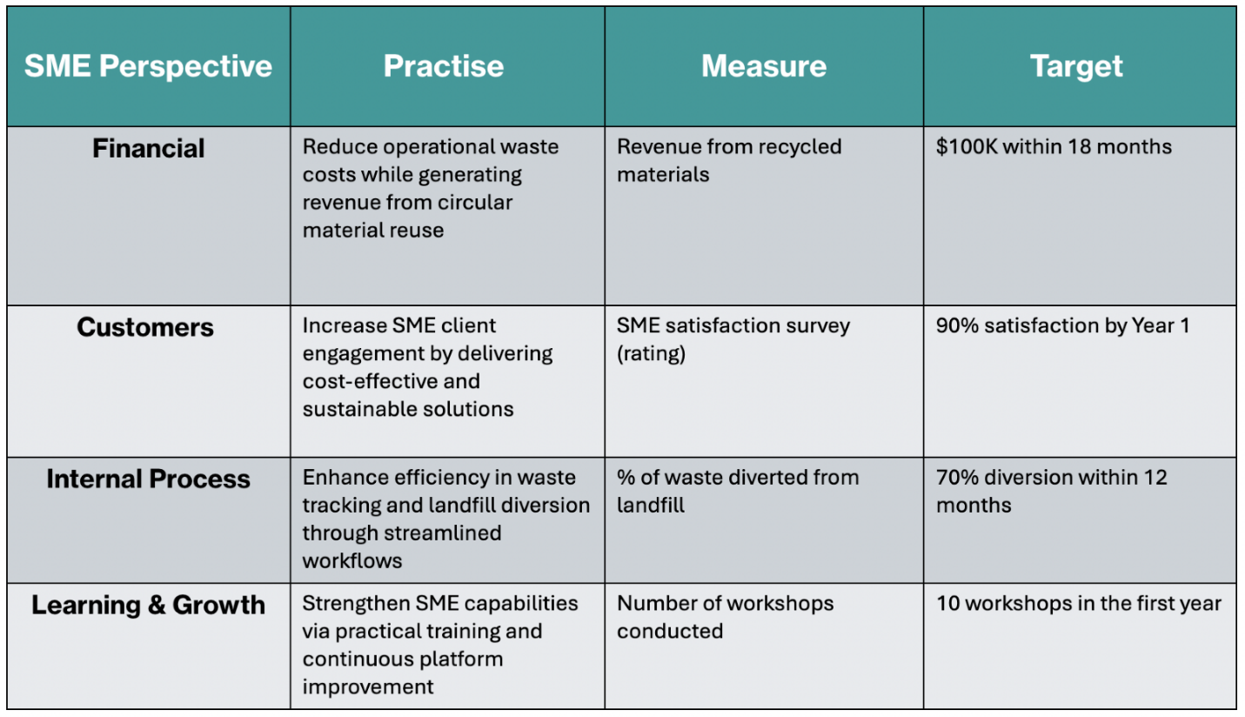
To ensure the correct execution of our innovation strategy in alignment SDG 9 (Industry & Innovation), SDG 12 (Responsible Consumption), and SDG 13 (Climate Action), we have employed the Balanced Scorecard framework in four key areas: financial, customer, internal processes, and learning and growth. This multi-view approach combines long-term sustainability objectives with operational performance.
From a financial perspective, it aims to save on waste disposal costs and generate new revenues from recycled products. These targets set will directly support sustainable value creation, as described by Kaplan and McMillan (2021), who highlight how modern BSCs must integrate ESG-linked financial outcomes to remain relevant.
Customer-oriented business practices priorities SME engagement and satisfaction with our waste-reduction platforms. SME has been under increased social presures to adpot a circular practice, to be able to provide measurbale environmental and cost saving outcomes becomes significant in client retention and word-of-mouth advocacy.
Internally, the process perspective focuses on how to best optimise waste monitoring and re-directed processes. By embedding circular economy mechanisms, it allows innovation to facilitate measurable reductions in landfilled offcuts, which improves operational efficiency. This is in alignment with the performance architecture.
Finally, learning and growth strategy addresses scaling impact through the training of staff, innovation, and feedback. The creation of sustainable BSC’s, as Zingales and Hockert's said (2003) you must cross assets, knowledge-sharing as well as awareness in the community to see long lasting, tangible results.
Combined, these measures combine to provide a dynamic implementation model that crosses strategy with everyday operations, allowing the organisation the aboltiy to rapidly scale, while creating environmental, economic, and social value.

Conclusion:

Australian SME manufacturing sectors generate high amounts of industrial waste, often with limited amounts being recycled. Our proposal for a circular economy platform solves this issue, combining manufacturer waste and recyclers to implement a waste platform, turning waste to profit. Aligned with SDG 9 (Industry & Innovation), SDG 12 (Responsible Consumption), and SDG 13 (Climate Action, the solution promotes economic and environmental sustainability. We have established measurable goals in financial, customer, internal, and learning areas. The next step involves testing the platform with experts obtaining feedback and tweaking the product to get it ready for service. This platform can make a major difference in changing the way waste management practices in the Australian Manufacturing landscape.

Reference List:
Advanced Manufacturing Growth Centre (AMGC) 2021, Sector Competitiveness Plan, viewed 25 May 2025, https://www.amgc.org.au/resources/.
Ai Group 2023, State of the manufacturing industry 2023, Australian Industry Group, viewed 20 May 2025, https://www.aigroup.com.au.
Allied Heat Transfer 2018, Allied Heat Transfer, viewed 25 May 2025, https://www.alliedheattransfer.com.au/.
Australian Bureau of Statistics (ABS) 2022, Counts of Australian businesses, including entries and exits, June 2017 to June 2022, viewed 25 May 2025, https://www.abs.gov.au/statistics/business-indicators/businesses/counts-australian-businesses-including-entries-and-exits/latest-release.
Australian Bureau of Statistics 2023, Circular economy, viewed 25 May 2025, https://www.abs.gov.au/statistics/measuring-what-matters/measuring-what-matters-themes-and-indicators/sustainable/circular-economy.
Business Recycling 2018, Planet Ark: Business Recycling, viewed 25 May 2025, https://planetark.com/programs/business-recycling.
Clean Energy Regulator 2022, National greenhouse and energy reporting (NGER) data, viewed 25 May 2025, https://www.cleanenergyregulator.gov.au.
Commonwealth Scientific and Industrial Research Organisation (CSIRO) 2021, National circular economy roadmap: Manufacturing focus, viewed 20 May 2025, https://www.csiro.au.
CSIRO 2022, Circular economy roadmap for manufacturing, viewed 25 May 2025, https://www.csiro.au/en/news/All/Articles/2022/February/Circular-Economy-Roadmap-For-Manufacturing.
CSIRO 2023, National circular economy roadmap: Manufacturing sector, CSIRO Publishing, Canberra.
CSIRO 2024, Advancing the circular economy, viewed 25 May 2025, https://www.csiro.au/en/research/environmental-impacts/sustainability/Circular-Economy.

Department of Agriculture, Water and the Environment 2019, National waste policy action plan 2019, Australian Government, viewed 25 May 2025, https://www.dcceew.gov.au/environment/protection/waste/publications/national-waste-policy-action-plan-2019.
Department of Climate Change, Energy, the Environment and Water 2022, National waste report 2022, Australian Government, viewed 20 May 2025, https://www.dcceew.gov.au.
Department of Industry, Science and Resources 2022, Australian manufacturing performance report, Australian Government, viewed 20 May 2025, https://www.industry.gov.au.
Department of Industry, Science and Resources 2022, Australian manufacturing statistics, viewed 25 May 2025, https://www.industry.gov.au/data-and-publications/australian-manufacturing-statistics.
Hadi, NU, Almessabi, B & Khan, MI 2025, ‘Leveraging Industry 4.0 and circular open innovation for digital sustainability: The role of circular ambidexterity’, Journal of Innovation and Sustainability, viewed 25 May 2025, https://www.sciencedirect.com/science/article/pii/S2199853125000800.
Kaplan, RS & McMillan, D 2021, ‘Reimagining the balanced scorecard for the ESG era’, Harvard Business Review, viewed 1 June 2025, https://hbr.org/2021/04/reimagining-the-balanced-scorecard-for-the-esg-era.
Mekonnen, T, Mussone, P & Bressler, D 2021, ‘Sustainable waste management strategies in manufacturing SMEs: A review’, Journal of Cleaner Production, vol. 296, 126438, viewed 25 May 2025, https://doi.org/10.1016/j.jclepro.2021.126438.
Neuberger, J, Weidner, T & Steane, ED 2019, ‘Circular economy hubs: The state of play’, Oxford Urbanists, 21 December, viewed 25 May 2025, https://www.oxfordurbanists.com/magazine/2019/12/21/circular-economy-hubs-the-state-of-play.
Samsara Eco – Wollemi Capital 2025, Wollemi Capital, 27 March, viewed 25 May 2025, https://wollemi.com/company/samsara-eco/.
Sustainability Victoria 2020, Waste generation and resource recovery in Victoria, State Government of Victoria, viewed 20 May 2025, https://www.sustainability.vic.gov.au.
Sustainability Victoria 2022, Recycling and resource recovery infrastructure plan, Sustainability Victoria, viewed 25 May 2025, https://www.sustainability.vic.gov.au.
Sustainability Victoria 2025, Waste data update, viewed 25 May 2025, https://www.sustainability.vic.gov.au/research/waste-data-update.
Zingales, FGG & Hockerts, K 2003, Balanced scorecard & sustainability: Examples from literature and practice, INSEAD Working Paper Series.

